**NAIT Crystal Ball – 5K Solutions**

NAIT Crystal Ball is an application that assists current and prospective students in selecting the program that is right for them. The system allows a user to enter their education and preferential information, which will result in a list of relevant programs that might be a good fit and any credits they may be eligible to receive. Furthermore, the system allows NAIT staff to add entrance requirements, preference question parameters, course equivalencies, and other parameters that will allow the system to properly match programs.

**Technical Details**

**Administrator**

The administrator role acts as one generic user account that relevant NAIT staff will have access to. Upon logging in, the administrator will be able to influence a wide variety of important parameters that will affect the program matching of the Crystal Ball Application.

1. Admin landing page – this is the umbrella page that the administrator will see upon logging in and provides access to a variety of admin actions.  
   
2. Manage Programs – This page allows the administrator to manage programs including adding new programs, and updating existing ones. A detailed walkthrough of this section can be found below:
   1. **Search Programs** – The user can search for a specific program or lookup all programs in a specific program category.  
      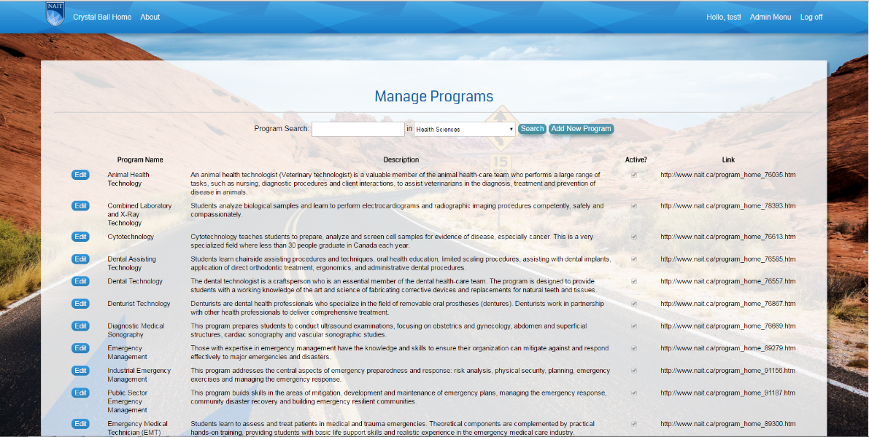
   2. **Manage Programs** – **Step 1: Manage Program Information** – The user can update the profile information including name, credential type, description, total credits, etc.  
      
   3. **Manage Programs – Step 2: Set Program Category** – The user sets the program categories that the program belongs to. This will affect search results and how the program is retrieved in drop down lists.  
      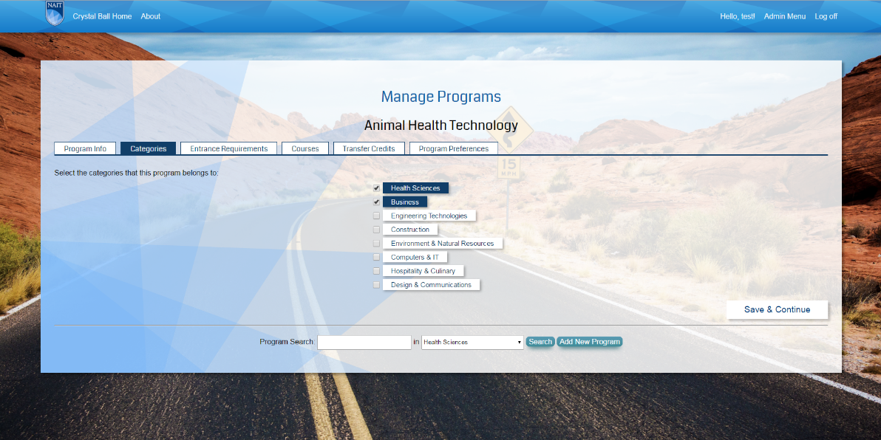
   4. **Manage Programs** – **Step 3: Set Program Entrance Requirements** – The user sets the entrance requirements for the program including high school courses and post-secondary courses (if relevant).  
      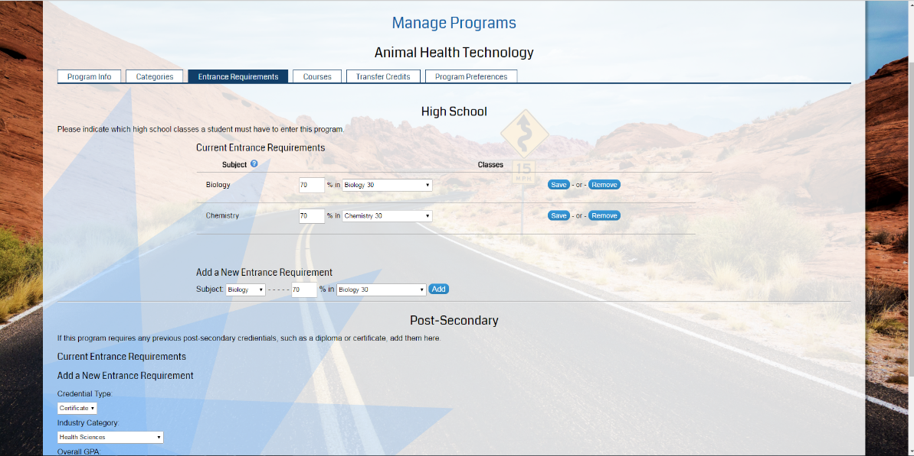
   5. **Manage Programs – Step 4: Add Program Courses** – The user sets what courses are part of the program.  
      
   6. **Manage Programs – Step 5: Set Transfer Credits –** If relevant, the user sets what courses are eligible for transfer credit and which courses provide said credit.  
      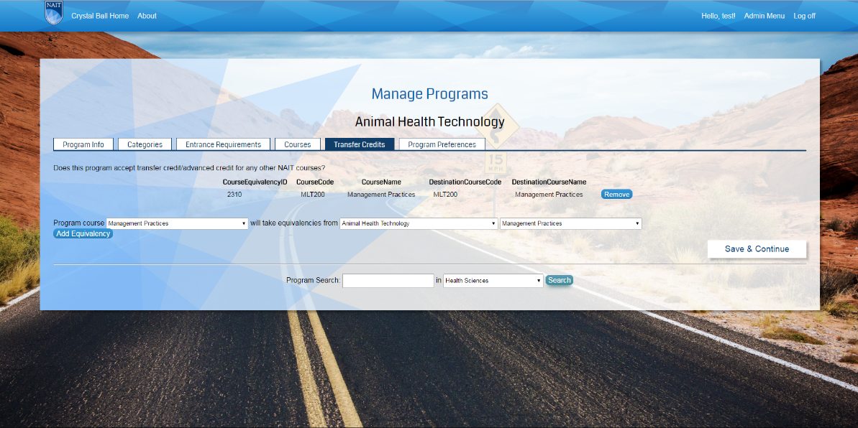
   7. **Manage Programs – Step 6: Set Program Preferences** – The user will set the expected program preferences that will result in a positive match between a prospective student’s preferences and the program preferences.  
      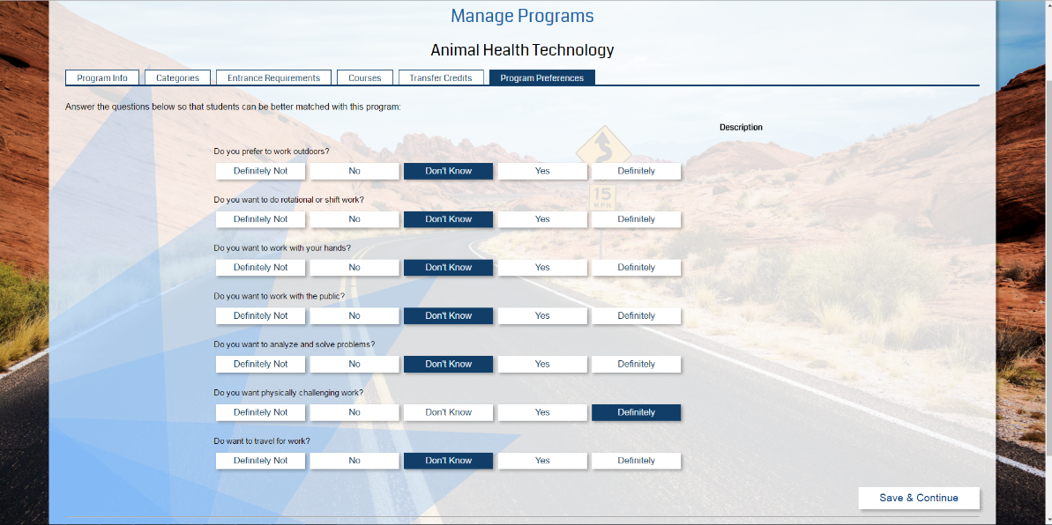  
        
      Once the administrator is satisfied with the parameters set for a particular program they can then save them, which will update the database entry for that program. **This cannot be undone once saved!**